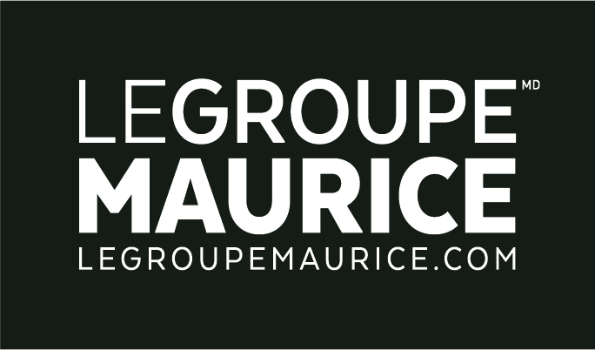
Press Release
For Immediate Distribution

Enough is enough!
LE GROUPE MAURICE CONTINUES ITS CRUSADE AGAINST AGEISM

MONTREAL, Oct. 1, 2021 – To mark National Seniors Day, Le Groupe Maurice is launching part 2 of its " I am the senior of tomorrow " campaign. After having seen, among others, the face of Hélène Bourgeois Leclerc aging rapidly, now Julie Le Breton and Gregory Charles will lend their features to this second phase.

“If we are returning with a new version of this campaign, it’s because despite the difficulties experienced by the elderly during the first wave of the pandemic, we’re still seeing many instances of aggressive ageism towards older people,” says Luc Maurice, President and Founder of Le Groupe Maurice.

A complete approach to raise awareness and to educate
Le Groupe Maurice is continuing its longstanding crusade of aging better, while condemning ageism. Its ad campaign is aimed squarely at informing the public about this form of discrimination and encouraging people to reflect and hopefully modify their behaviours.

To achieve this, several initiatives aimed at educating and raising awareness have been developed to complement television and print messages, which can be found on the jesuislainededemain.com landing page. Firstly, a questionnaire was created so that Internet users could recognize certain behaviours bordering on ageism. In order to encourage people to answer, The Luc Maurice Foundation agreed to donate two dollars to an organization working with seniors, after each duly completed questionnaire.

With ageism mainly affecting seniors, Le Groupe Maurice decided to put them at the heart of their campaign. Host and director Jean-Pier Gravel personally met with seniors to fully-understand what ageism means to them. Sometimes funny, other times moving… many unique moments were captured on video. The results, displayed on the website landing page, have already left many smiling.

On the site, you’ll also find Le Groupe Maurice’s very first podcast, featuring Mr. Luc Maurice, expert commentators and of course – seniors! Various subjects discussing the reality of the elderly are approached in a compassionate way through enlightening conversations and passionate exchanges. Finally, to mark the occasion in a highly visible fashion, why not walk with and for them? On October 1st, a large symbolic march was organized by each Le Groupe Maurice residence to celebrate National Seniors Day, as it should be! Banners, messages, high-energy and good humour were on the agenda. The success of this initiative encouraged the organizers to make it a yearly tradition!

A campaign with a social purpose
Why does Le Groupe Maurice want to "Hit the nail on the head" once again with these initiatives? Because according to the World Health Organization (WHO), ageism may now be even more prevalent than sexism or racism. This is because this type of discrimination takes many forms, whether by sneakily entering our discourse or by colouring government policies or decisions. We have witnessed an increase in ageism with the arrival of COVID-19; the lack of resources dedicated to seniors is a direct result of a lack of societal consideration for the aging population.

"The denunciation of ageism serves not only to defend the rights of older people, but also, and above all, to ensure that they can assume responsibility, take the place they deserve and contribute to society as they wish," adds Rita Kataroyan, Vice-President of Marketing and Communications of Le Groupe Maurice.

For Le Groupe Maurice, acting now means not only helping today's seniors, but also ensuring a better life for all future generations of retirees. Ageism is a complex, misunderstood and even taboo problem. Today more than ever, it’s essential to dust it off, talk about it and outright denounce it. Since combatting ageism is truly in everyone's interest, we must take ownership of the problem.

