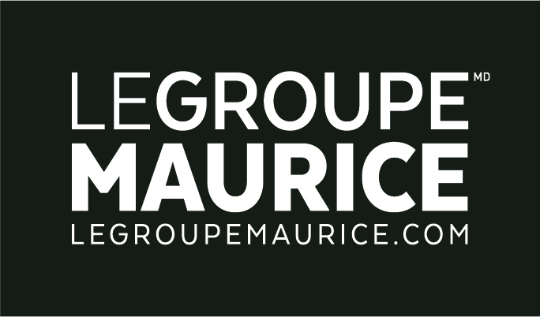
Press Release
For Immediate Distribution

COVID-19 SITUATION: EMPLOYEE BONUSES
“BECAUSE YOUR SMILE IS THE ONLY TRACE OF NORMALCY IN RESIDENTS’ LIVES”

MONTREAL, April 3, 2020 – In this time of the pandemic where there are so many brave individuals to thank, we at Le Groupe Maurice would like to pay tribute to our very own guardian angels; those who are “present” every day in our residences to help our retirees.

While their hard work has often been praised, Le Groupe Maurice wanted to materialize these "thanks", by rewarding its many dedicated employees. This will be in the form of monetary bonuses, free meals on working days, extra vacation time, availability of resources for medical or psychological help, and more. Well-deserved rewards to warm many hearts during this difficult time.

While making this announcement, the words of company president Luc Maurice also moved many. “The greatness of what you do can only be measured by words of gratitude. Each of the actions you take on a daily basis, your very presence, your smile and kind words towards the residents… all redefine the notion of humanism. It is the greatest form of generosity you can offer and I am eternally grateful to you.”

