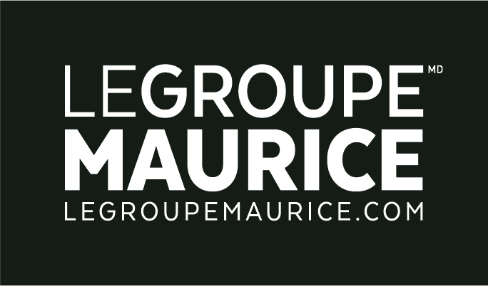
Press Release
For Immediate Distribution

LE GROUPE MAURICE INKS A FINANCIAL PARTNERSHIP WITH VENTAS

MONTREAL, June 3, 2019 – Le Groupe Maurice, a leader in the design, development and management of avant-garde retirement residences in Quebec, is pleased to announce the arrival of Ventas Inc. as a new financial partner of the company.

Founded almost 20 years ago, Ventas is one of the world's largest real estate investment trusts (REITs) with over 1,200 properties in the United States, Canada and the United Kingdom. Its success is based on the strategic partnerships it establishes with leading property managers. Ventas collaborates with more than 200 property managers, several of which operate Private Seniors’ Residences (PSR). As the second largest owner of seniors' residences in the United States, and with a significant presence in Canada, Ventas's expertise and commitment to seniors is undeniable.

The values, approach and work ethic of Ventas align perfectly with those of Le Groupe Maurice. The agreement between the two entities will officially come into effect this summer. It will allow Le Groupe Maurice to accelerate its long-term development plan, where the needs are immense in terms of new senior housing complexes throughout Quebec. “Throughout this process, our priority was to ensure the sustainability of our business, while maintaining the distinctive attributes of our brand, which are the basis of our success. In this sense, I’m convinced that Ventas is a partner of choice. A partner that will enable us to continue contributing to the better aging of thousands of seniors and respond even better to their needs and aspirations,” declared Luc Maurice, the Founder and Chairman of Le Groupe Maurice.

The transaction sets the value of Le Groupe Maurice's real estate portfolio at CDN$2.4 billion. "We are delighted to announce the conclusion of this partnership with Le Groupe Maurice, one of the most prominent operators in Quebec with a distinctive portfolio showing growth potential in promising and attractive urban markets," said the President of the Board and CEO of Ventas, Debra A. Cafaro. She also added, “This transaction enhances and diversifies our quality portfolio and underscores the success of our partnership strategy with benchmark operators and developers.”

The arrival of Ventas as a financial partner of Le Groupe Maurice comes at the expiration of its agreement with Ipso Facto, an investment partner for more than fifteen years. “Ipso Facto's financial support over the years has helped make Le Groupe Maurice a leader in PSRs in Quebec,” said Mr. Maurice. "It is with great enthusiasm that we begin this new chapter with the arrival of Ventas, which will enable our company to pursue its mission with efficiency and humanity," concluded Mr. Maurice.

What’s made us great, remains the same!
The agreement with Ventas will not lead to any change in the regular workings of the company, which will continue its normal operations in all 36 of its residences and projects. The management team is also remaining in place under the leadership of founder and president, Luc Maurice. All teams in the field will continue offering residents the quality of services that have earned Le Groupe Maurice its unparalleled reputation and respect among the Quebec public; to the point of becoming the benchmark in senior housing complexes.

National Bank Financial Inc. and the McCarthy Tétrault law firm acted respectively as financial advisor and legal strategic advisor in the completion of this transaction.

