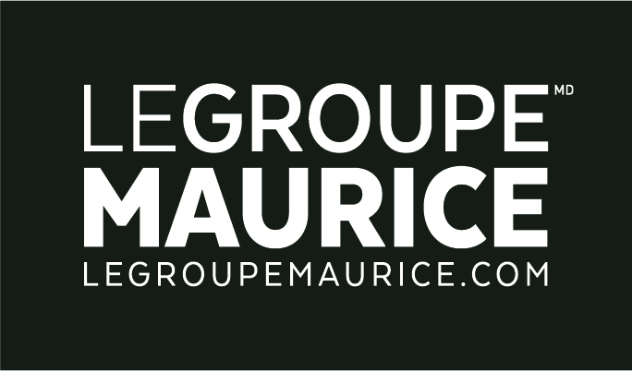
Press Release
For Immediate Distribution

THE 50 BEST MANAGED COMPANIES IN CANADA
Le Groupe Maurice takes the GOLD. Again.

MONTREAL, March 7, 2019 – It is with great pride that Le Groupe Maurice, for the 5th consecutive year, has once again distinguished itself in the Gold Category as one of Canada’s 50 Best Managed Companies.

“For me, this requalification goes beyond the recognition of our solid financial performance, substantial productivity and sound management team. Being named one of the 50 Best Managed Companies demonstrates that together, we have managed to maintain the balance between the happiness of our customers, the commitment of our employees, the trust of our partners and the enrichment of the communities we are a part of. It allows us to innovate and continue to evolve positively in our understanding of the needs of Quebec retirees by ensuring that this balance is preserved, that our mission is pursued and that our values are respected."
– Luc Maurice, President of Le Groupe Maurice.

This award thus reaffirms Le Groupe Maurice's deep desire for excellence. Not only in a competitive business context within its industry, but first and foremost, for the benefit of the 10,000 residents and 2,000 employees in its 34 retirement residents in Quebec.

About Canada's Best Managed Companies
Canada's Best Managed Companies continues to be the hallmark of excellence for Canadian-owned and managed companies with annual revenues over $15 million. Each year since the competition was launched in 1993, hundreds of companies participate in a rigorous, independent process to assess their management capabilities and practices. Program sponsors are Deloitte, CIBC, Canadian Business, Smith School of Business, TMX Group, and MacKay CEO Forums.

