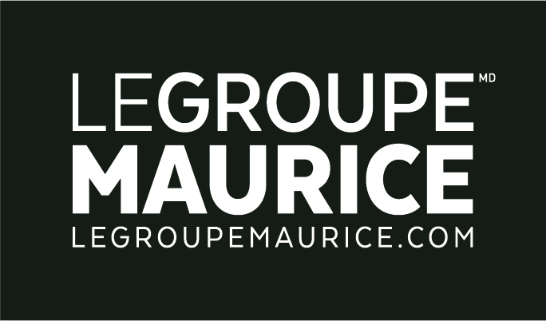
Press Release
For Immediate Distribution

Le Groupe Maurice’s CALÉO project obtains LEED Silver
Certification from the U.S. Green Building Council (USGBC)

MONTREAL, September 10, 2018 – Having officially opened its doors on July 1st in Boucherville, seniors’ residential complex CALÉO officially received LEED Silver Certification from the U.S. Green Building Council (USGBC).

“This distinction, of which I am extremely proud, is recognized as the international mark of excellence for sustainable buildings. It embodies Le Groupe Maurice's commitment to make CALÉO a living and working environment that is as dynamic as it is ecological, without compromising the functional and aesthetic aspects of a retirement residence.”
– Luc Maurice, President of Le Groupe Maurice.

During CALÉO’S 19-month construction period, Le Groupe Maurice made sure to favour the appropriate components and materials to ensure the residence would offer seniors a high environmental quality. The following achievements made it possible to attain the necessary credits for LEED Silver Certification:
- Promotion of transport electrification with the presence of electrical terminals on the project.
- Installation of water-saving devices in units, with performance certified by WaterSense. Water savings of 20% on all the housing units of the project, i.e. almost 1 million litres of water saved per month and 4 Olympic-size swimming pools per year.
- Energy efficiency of the building meeting the target of 17% energy cost savings (compared to the ASHRAE 90.1 2007 standard).
- Increased thermal comfort in the housing units with the installation of heat pumps in each room, so as to respond precisely and efficiently to the heating and cooling needs during certain periods of the year.
- LEED credit for better airtightness performance, which guarantees less air leakage to the outside, and less noise and odour transmission between dwellings.
- LED lighting throughout the building. The energy savings is between 70-90% compared to incandescent lighting products.
- Reduced risk of water damage in apartment units: All washers are equipped with a floor drain and other measures to prevent water damage in the apartment.
- Vinyl floors certified by Floorscore® to guarantee a low emission rate of VOCs (Volatile Organic Compounds)
- Proximity to a very large number of community resources and Vincent d'Indy Park: no need for a car for these trips.
- Landscaping: Use of topsoil as backfill under the landscaping.

About LEED Certification
Leadership in Energy and Environmental Design (LEED) is a voluntary program that provides an approach to designing, constructing, managing and evaluating high-performance buildings. This rating system is recognized as the international mark of excellence for sustainable buildings in more than 132 countries. It aims to encourage sustainable construction methods, particularly in terms of energy efficiency, water consumption, heating, etc.

