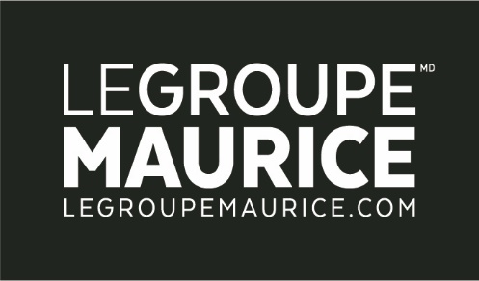
Press Release
For Immediate Distribution

THE LUC MAURICE FOUNDATION WILL DISTRIBUTE $10 MILLION OVER FIVE YEARS
TO PROMOTE THE HAPPINESS AND WELL-BEING OF THE ELDERLY

MONTREAL, November 14, 2017 – The President and Founder of Le Groupe Maurice, Mr. Luc Maurice, today announced the creation of a foundation that will distribute a minimum of ten million dollars over the next five years. The funds will support organizations, individuals and causes that contribute to the well-being and development of seniors in Quebec, by allowing them to continue to expand their desires for greater happiness.

The official launch of the Luc Maurice Foundation took place as part of the 2017 Summit on Philanthropic Culture (an initiative of the Mallet Institute), which is being held until tomorrow at the Palais des Congrès of Montreal.

“A report produced by the Mallet Institute and presented as part of the 2017 Summit on Philanthropic Culture, shows that the number of private foundations in Quebec have experienced a whopping 57% growth between 2005 and 2015. The creation of the Luc Maurice Foundation is a prime example of this trend; of the desire of individuals to make a real difference in their community. Indeed, we must salute these kinds of initiatives!”
– Jean M. Gagné, President and CEO of the Mallet Institute.

According to Luc Maurice, "Beyond meeting our basic needs, we should all be able to live according to our core values, and above all, to grow old as happy as possible until the end of our lives”. In his view, the success of society cannot be measured merely in terms of economic development. It must also be measured by the ability of our communities to make people happy.

“In 2017 alone, we distributed more than $1 million to organizations working for the well-being of seniors. We will continue to actively support these partners through our new foundation. This will initiate more official governance, allowing us to broaden our pool of donors to further assist the organizations and people working to help seniors in Quebec. It will also give us an even stronger voice to promote the importance of this cause."
– Luc Maurice.

Health, socialization and high esteem of the elderly
The nature of the Luc Maurice Foundation is quite unique. It is here to support organizations whose activities affect the health, socialization and appreciation of seniors – a first in Quebec. “These are the three factors that significantly contribute to the happiness of older people. In fact, a recent Léger survey has confirmed what we have been seeing for 20 years with our residents. This is why our Foundation will favour organizations that demonstrate a human approach and constantly innovate in order to establish a bond with seniors to meet their needs.” added Luc Maurice.

