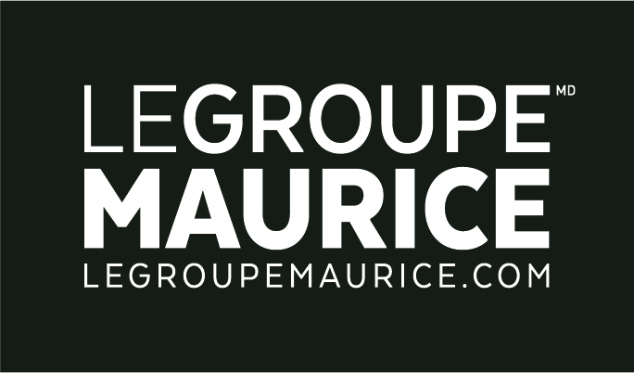
Press Release
For Immediate Distribution

WISDOM COMES WITH AGE. AS DOES HUMOUR!

MONTREAL, July 18, 2019 – The curtain came down to the thunderous applause of a delighted audience at the Gala des retraités, where 10 courageous Groupe Maurice residents took to the stage of the Monument-National. Stand-up comedy was alive and well as part of the Just for Seniors program, a partnership between Le Groupe Maurice and the Just for Laughs Festival.

Trained by a professional from the National School of Humour, these one-night stand-up seniors presented entertaining stories and jokes. In fact, the humour became more and more hilarious as the exclusive show unfolded. Generating so much laughter, the public could clearly see that the years hadn’t slowed down these venerable apprentice comedians.

Quotations:
“The elderly are a very well-kept secret! The Gala des retraités is a unique concept that showcases the audacity, epicurean way of life and taste for adventure that seniors have. Through their fearless exploits, they prove that just because the decades are piling up, doesn’t mean they still can’t have fun! For Le Groupe Maurice, this Gala represents an additional opportunity to shine the spotlight on seniors, while celebrating age in a different way.”
– Luc Maurice, President and Founder of Le Groupe Maurice

“Knowing how to make those around you laugh is one thing. Being able to take that onto a stage and make strangers laugh, is quite another. It may seem easy at first glance, but the challenge our senior comedians took up tonight, is the result of hours of work, rewriting and rehearsing that I had the privilege of witnessing. The feat they achieved is absolutely impressive. They have much to be proud of!”
– Patrick Tremblay, Super-trainer and host of the Gala des Retraités

