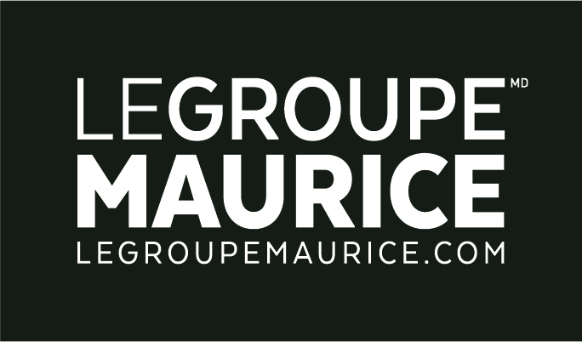
Press Release
For Immediate Distribution

2020 MERCURIADES WINNER
Le Groupe Maurice, “limitless terminals”!

MONTREAL, September 29, 2020 – It is with the development of THÉIA, the very first mobile app in the private seniors’ residences industry, that Le Groupe Maurice secured its third Mercure trophy. This time around, the company distinguished itself in the “Development of web or mobile technology” category of the prestigious Les Mercuriades business competition.

In a context where the current pandemic has turned the world of many companies upside down, forcing some to rethink their operating methods and modify their discourse, one element has not only remained intact at Le Groupe Maurice, but has taken on even more meaning: its values! This nomination thus crowns the Group's commitment, ambition and constant efforts to push the limits of innovation and break through the restrictive barriers that have categorized, for too long, the way of life, the aspirations and the needs of seniors.

THÉIA: Everyday life at your fingertips
It was in 2017 that the company anchored the foundations of its vision with the first tools of a multidisciplinary and innovative ecosystem; namely the community television channel and interactive terminals situated in the common areas of all the complexes that support residents in their daily lives. The launch of the Groupe Maurice THÉIA mobile app thus represented the logical continuation of this successful project and marked a turning point in the world of in-residence communication.

By making information relating to the residents' daily lives accessible (activity schedule, dining room menus, important alerts, news of the day, photo gallery, etc.) at any time and in any place, THÉIA represents an additional opportunity for Le Groupe Maurice to fulfil the promise made to seniors since the company's inception: to create living environments in response to their aspirations!

Quotation:
“For us, the real innovation in this project goes beyond the solution itself: we have developed an innovative, superior quality tool, specifically designed for a segment of the population that has been deprived of it for too long! But beyond its bold nature, THÉIA also represents the creation of an additional link with our customers. A privileged link that allows the company to continue its expansion while remaining ‘close to its world’. And for my colleagues and myself, there’s nothing more precious!”
– Rita Kataroyan, VP Marketing and Sales.

