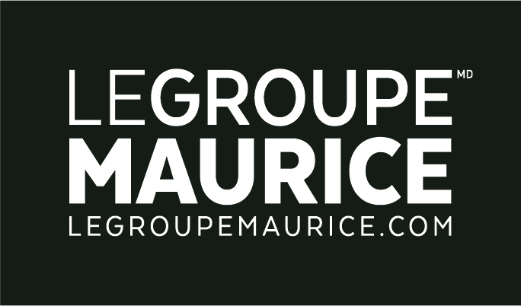
PRESS RELEASE
FOR IMMEDIATE DISTRIBUTION

Together, let's choose a world without ageism!
Le Groupe Maurice Is Actively Committed To The Fight Against Ageism

MONTREAL, September 6, 2022 – By the year 2030, 25% of Quebecers will be seniors according to the National Institute of Public Health of Quebec. Paradoxically, one in two people display ageism towards seniors and ageism is the most socially tolerated form of discrimination according to the UN. This is why Le Groupe Maurice is committed to continuing its efforts to raise awareness of ageism through the third instalment of its I Am a Senior of Tomorrow campaign.

In this latest iteration launched on September 4th, Le Groupe Maurice invites Quebecers to choose a world without ageism and to find solutions to do away with this prevalent social issue. This initiative takes on even more significance as the election approaches, a period when the general populace is in a mood of reflection and awareness of certain realities, such as the elderly’s place in society and our behaviour toward them.

An ad campaign to raise awareness
Throughout the campaign, the population will once again witness the powerful concept of people "aging in real time". This will be expressed via television commercials, print publications, posters and the Internet. The goal is to encourage people of all ages to put themselves in the shoes of today's seniors and to make them aware of certain persistent prejudices against this segment of the population. “Ageism does not always happen deliberately. It isn’t necessarily out of malice or a desire to exclude. Very often, people who have an ageist attitude don't even realize it! This is where education plays an extremely important role,” says Rita Kataroyan, Vice-President of Marketing and Communications, at Le Groupe Maurice.

In tandem with the campaign will be a quiz aimed at overturning stereotypes and false ideas regarding old age. This, along with full details of our advertising campaign, can be found online at JeSuislAineDeDemain.com. Furthermore, for each duly completed quiz, The Luc Maurice Foundation will donate two dollars to an organization working with seniors. Beginning mid-September, an awareness offensive will also be deployed on social networks to stimulate awareness of the scope of ageism in our society.

The time to act is now
With the attention surrounding the dismissal of newscaster Lisa LaFlamme, ageism is now especially in the public eye. Encouraging better aging and pushing back against ageism are core values at Le Groupe Maurice – and have been for many years. However, there is still a lot of work to be done to debunk many myths regarding the elderly.

To combat the insidious scourge of ageism, it is imperative to focus on the individual’s strengths, distinctivness and knowledge; we must stop generalizing. Each generation is essential for societal balance. "Ideally, we would all work together toward absolute inclusion so that older people could continue to fully-contribute to society. Let's hire them. Prioritize them. Give them back the power that belongs to them," emphasized Ms. Kataroyan. Shattering ageism is a way to preserve future generations of seniors. Which in turn ensures a better future for us all!

Seniors’ walk on Seniors’ Day
What better way to get involved and meet seniors than to walk WITH and FOR them? On the occasion of National Seniors’ Day, October 1st, a large festive march will be organized by the team of Un et un font mille and Le Groupe Maurice to celebrate and support our seniors. It is by appreciating the elderly and giving them the necessary resources to age better, that we will all be able to live better.

For today and tomorrow… it’s high time that together, we choose a world without ageism!

About Le Groupe Maurice
Le Groupe Maurice (LGM) is a leader in the design, development and management of modern residences for autonomous and semi-autonomous seniors in Quebec. Founded in 1998, the company now has over 2,000 employees, a seasoned management team with deep industry knowledge and an unparalleled reputation in both development and operations. LGM has grown from a single property in 2000, to thirty-four communities, all purpose-built and maintained to the strictest industry standards. LGM is a highly regarded brand that embodies the concept of "better ageing", much to the delight of its cherished residents.

– 30 –

Information / Media Contact
Marie-Ève Généreux
Director, Corporate Communications
Le Groupe Maurice
438 372-1298 | relations.medias@legroupemaurice.com

