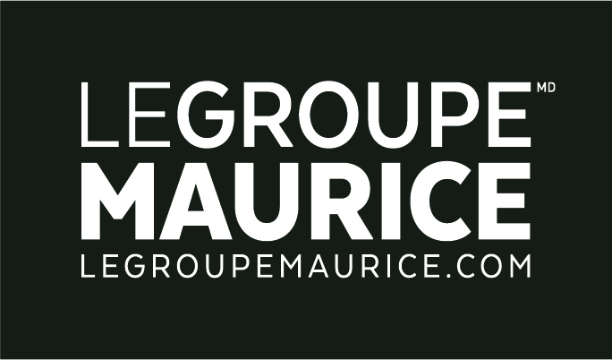
PRESS RELEASE
FOR IMMEDIATE DISTRIBUTION

Le Groupe Maurice Ushers In Its Newest
Seniors’ Residence In Montreal: Cornelius!

Montreal, November 4, 2022 – Le Groupe Maurice officially unveiled Cornelius today, its 34th complex for retirees situated in the Côte-des-Neiges district of Montreal. With this innovative project located within a recently modernized shopping centre, the company is continuing its growth and commitment to “better ageing” in Quebec. The occasion saw guests discovering this exceptional residence in a festive and friendly way.

The inaugural event was held in the presence of a hundred residents, employees, business partners and special guests including:
• Luc Maurice, Executive Chairman and Founder of Le Groupe Maurice
• Alain Champagne, President and Chief Executive Officer
• Michelle Setlakwe, MPP for Mount Royal–Outremont
• Gracia Kasoki Katahwa, Borough mayor, Côte-des-Neiges–Notre-Dame-de-Grâce

The first residents of Cornelius began arriving this past June. Le Groupe Maurice is proud to be providing Montrealers with a booming residential and commercial offering to help in the revitalization of neighbourhood life. Indeed, with the complex located right within the new Wilderton Shopping Centre, residents have privileged access to various local services in a freshly energized environment.

Quotes
"The legacy we wish to leave goes far beyond the buildings we erect. It is our contribution to better ageing for Quebec seniors and the enhancement of communities. To this end, with Cornelius, a residence of which I am particularly proud, I humbly strive to influence the way in which seniors are treated not only in Montreal, but throughout the province.”
– Luc Maurice, Executive Chairman and Founder of Le Groupe Maurice.

“What better a way to be welcomed into the Groupe Maurice family, than to attend the inauguration of this exceptional project surrounded by its residents and the team. Cornelius is a magnificent place that’s the product of a creative, innovative and compassionate team. We are all very proud!”
– Alain Champagne, President and CEO of Le Groupe Maurice (as of October 2022).

"Since the outset of this great adventure, my team and I have made it our duty to offer the residents of Cornelius an environment based upon their needs and desires. To that end, each day we continue building upon the moments and experiences that we all share. It’s truly a distinct honour to launch this wonderful residence of which I am so proud.”
– Olivier Tibika, General Manager of Cornelius.

About Cornelius
At the intersection of Van Horne and Darlington Avenues, the Cornelius residence resides within the new Wilderton Shopping Centre, now completely transformed to boost the commercial offering of the sector. The complex provides residents with direct access to a Pharmaprix pharmacy, a Metro grocery (a first in Montreal) on the second floor, restaurants, a banking institution and numerous other businesses and services. Comprised of 288 serviced apartments, the grand 12-storey residence offers breathtaking views of Montreal’s most emblematic sites from its two magnificent terraces.

