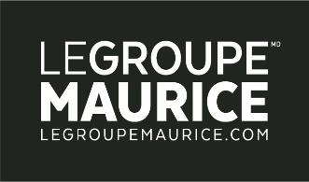

**C Press Release** For Immediate Release

**Survey on private residences for seniors**

***Le Groupe Maurice obtains the highest satisfaction level***

**Montreal, January 20, 2023** – A recent satisfaction survey published by *Protégez-vous* magazine shows that Le Groupe Maurice has the highest satisfaction rate among some 3,500 people living in private residences for seniors interviewed in a large-scale survey conducted by the magazine across Quebec.

With a satisfaction score of 75%, Le Groupe Maurice topped the list among Quebec retirement homes (including large groups and independent residences). Its residences are particularly strong in the areas of recreational activities, safety measures and staff courtesy.

**“The *Protégez-vous* survey results reflect Le Groupe Maurice’s unswerving commitment to providing outstanding residences in which retirees across Quebec can find comfortable living environments designed to foster autonomy, social activities, health and personal development in a freedom-focused setting,” said** Rita Kataroyan, Vice-President of Marketing and Communications.

Ms. Kataroyan underscored the tremendous work of the Groupe’s 2,100 employees who, day in and day out, help make the Le Groupe Maurice residences such exceptional living spaces–the overwhelming choice of retirees in Quebec.